ROCHESTER ART CENTER

MINI GOLF INSPIRED CHAIR OPTIONS

Please use this document to select one chair that will inspire your design for one mini golf hole. Thank you for considering applying to this call!

The chairs in this document belong to a private collection and will be exhibited along with mini golf at the Rochester Art Center from November 13, 2024 - May 4, 2025. Among the many wonderful chairs in the collection, we chose sixteen that we believe exemplify a variety of aesthetic choices, innovative manufacturing techniques, a range of construction materials, and compelling references to history, culture and nature. Eras that span from 1900 to the 2010s are represented among this selection.

Each chair is accompanied by:
- a short description with the chair’s historical relevance
- biographical information about the designer/architect
- a reference to architectural projects that insert the chair into the architect’s larger practice
- keywords and additional links for research.

For questions, email Curator Zoe Cinel at zcinel@rochesterartcenter.org.

Application Guidelines
Applicants must live and work in Minnesota, Iowa, North Dakota, South Dakota or Wisconsin to be eligible.

Click here to access the application form.

Rochester Art Center website: www.rochesterartcenter.org

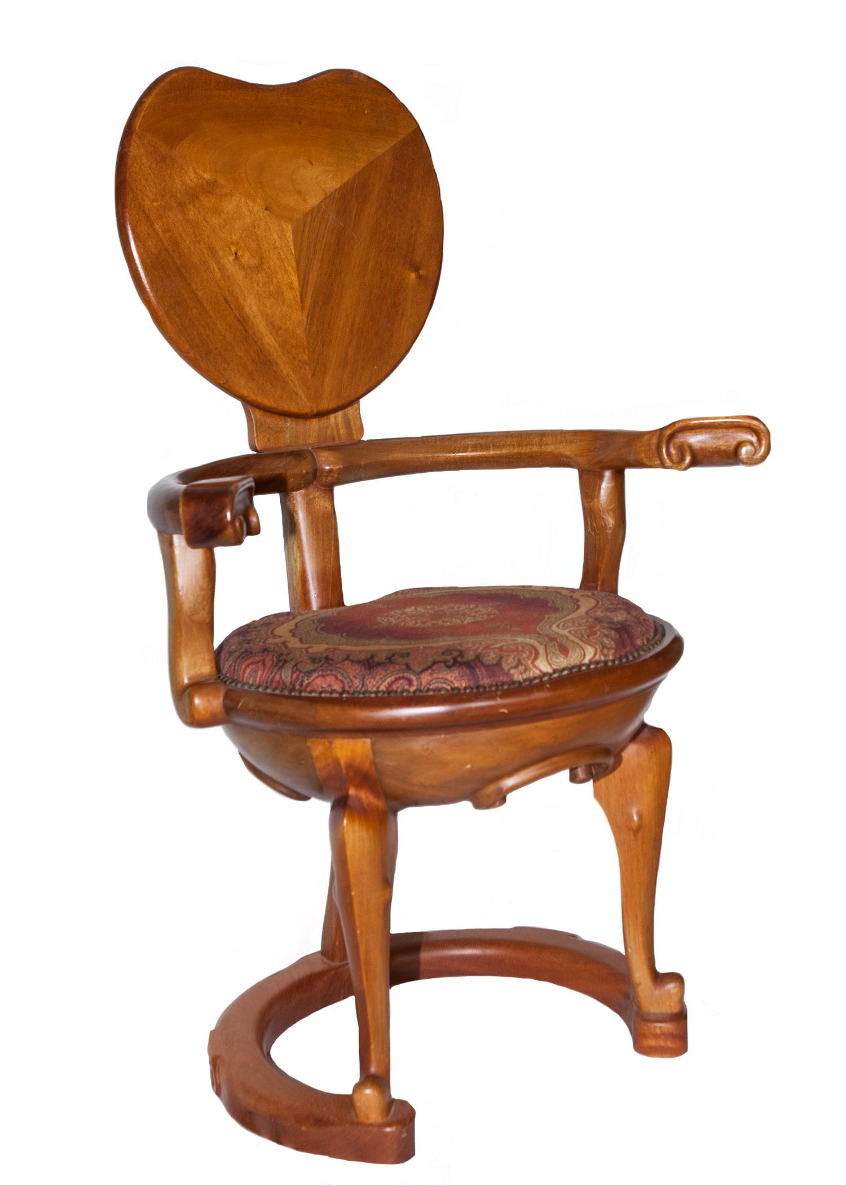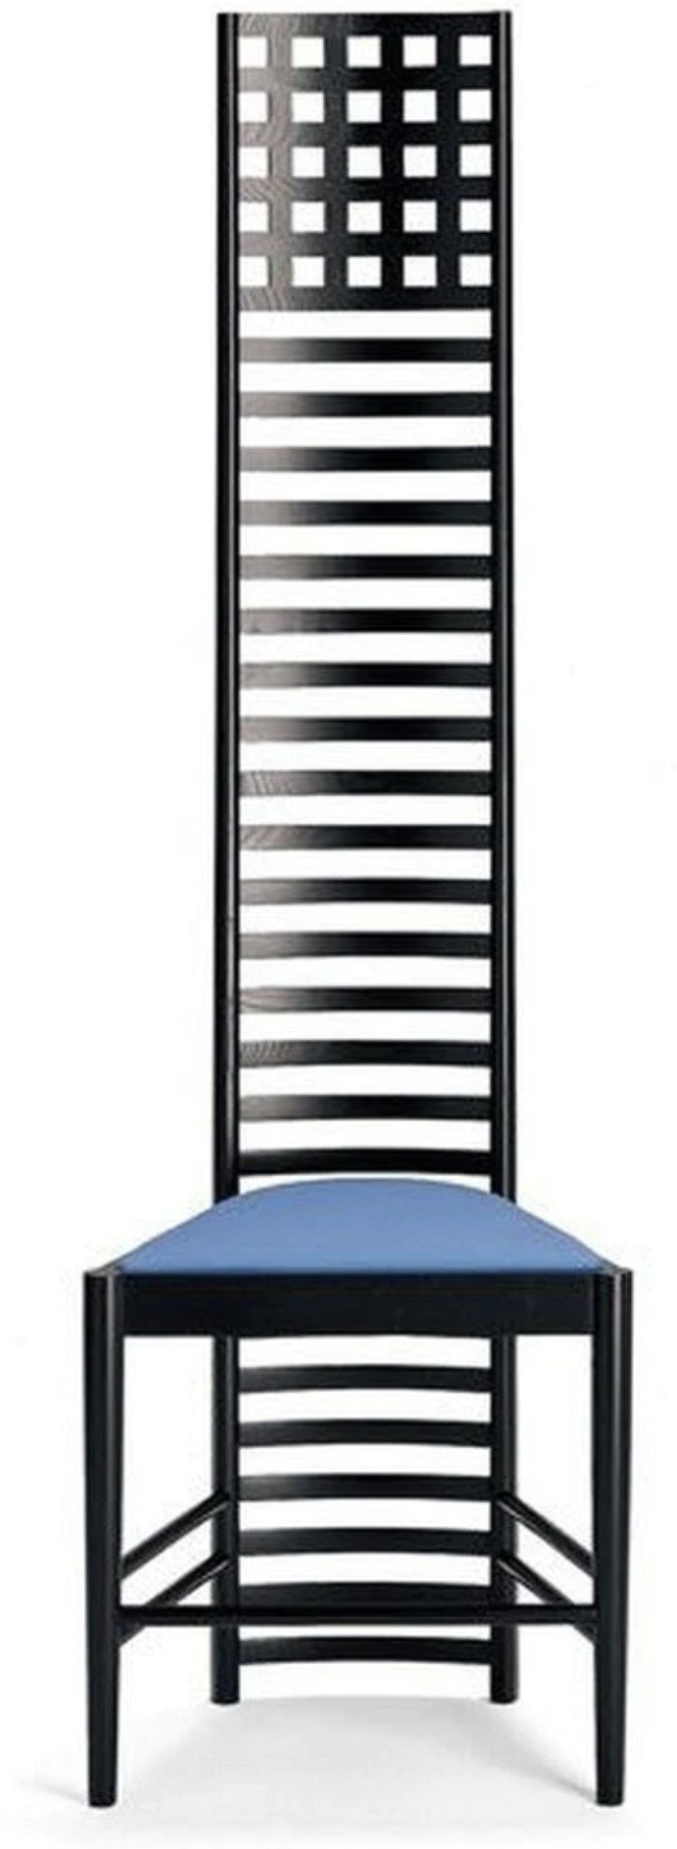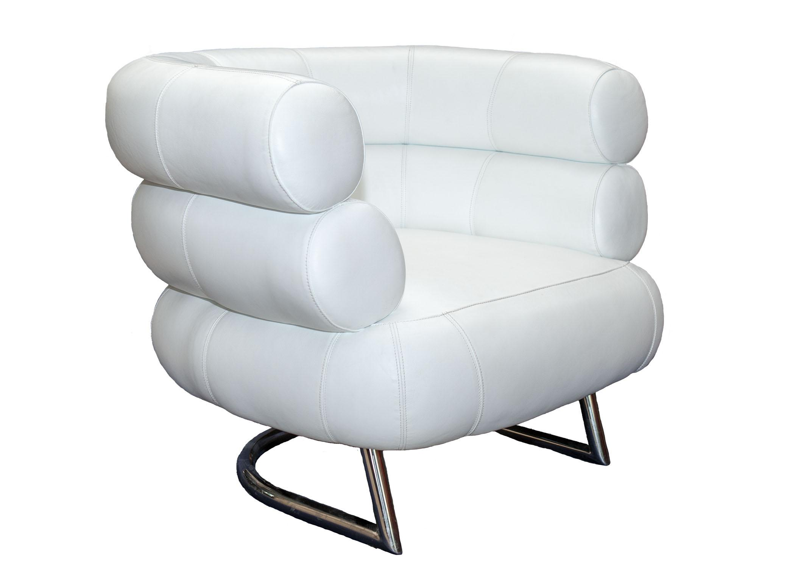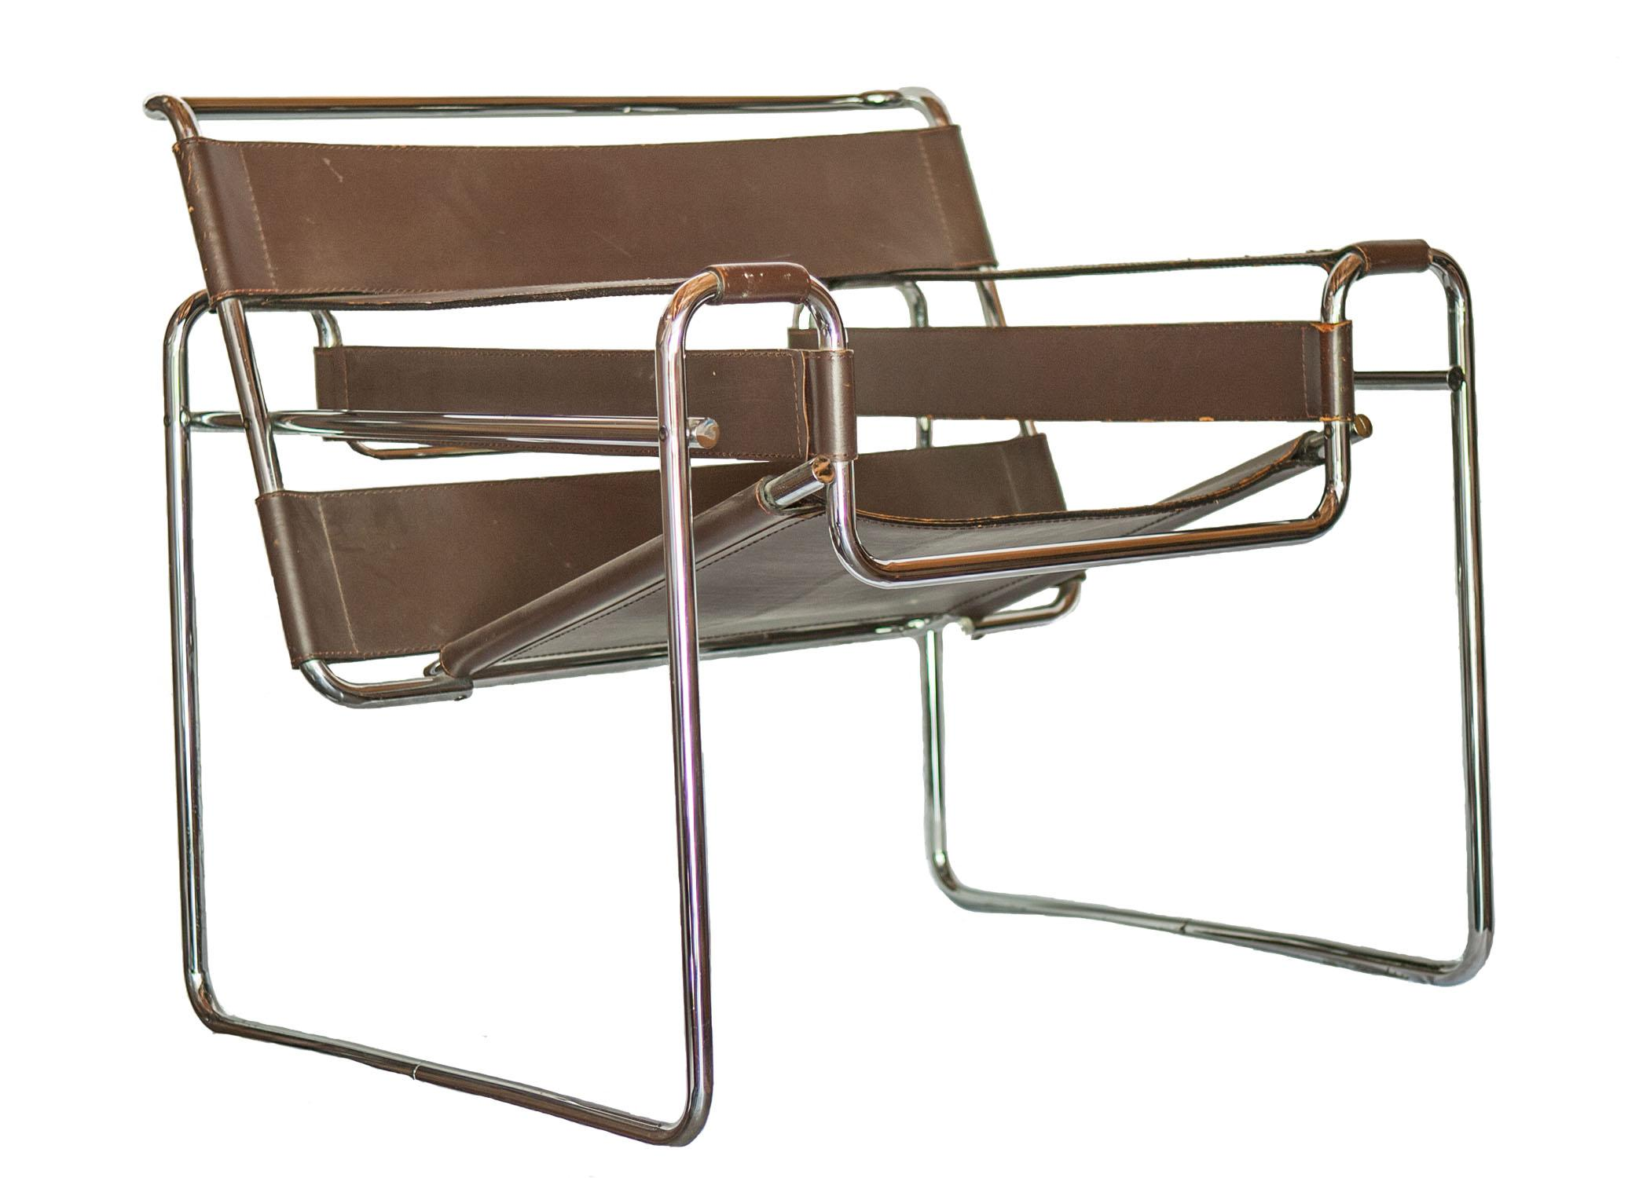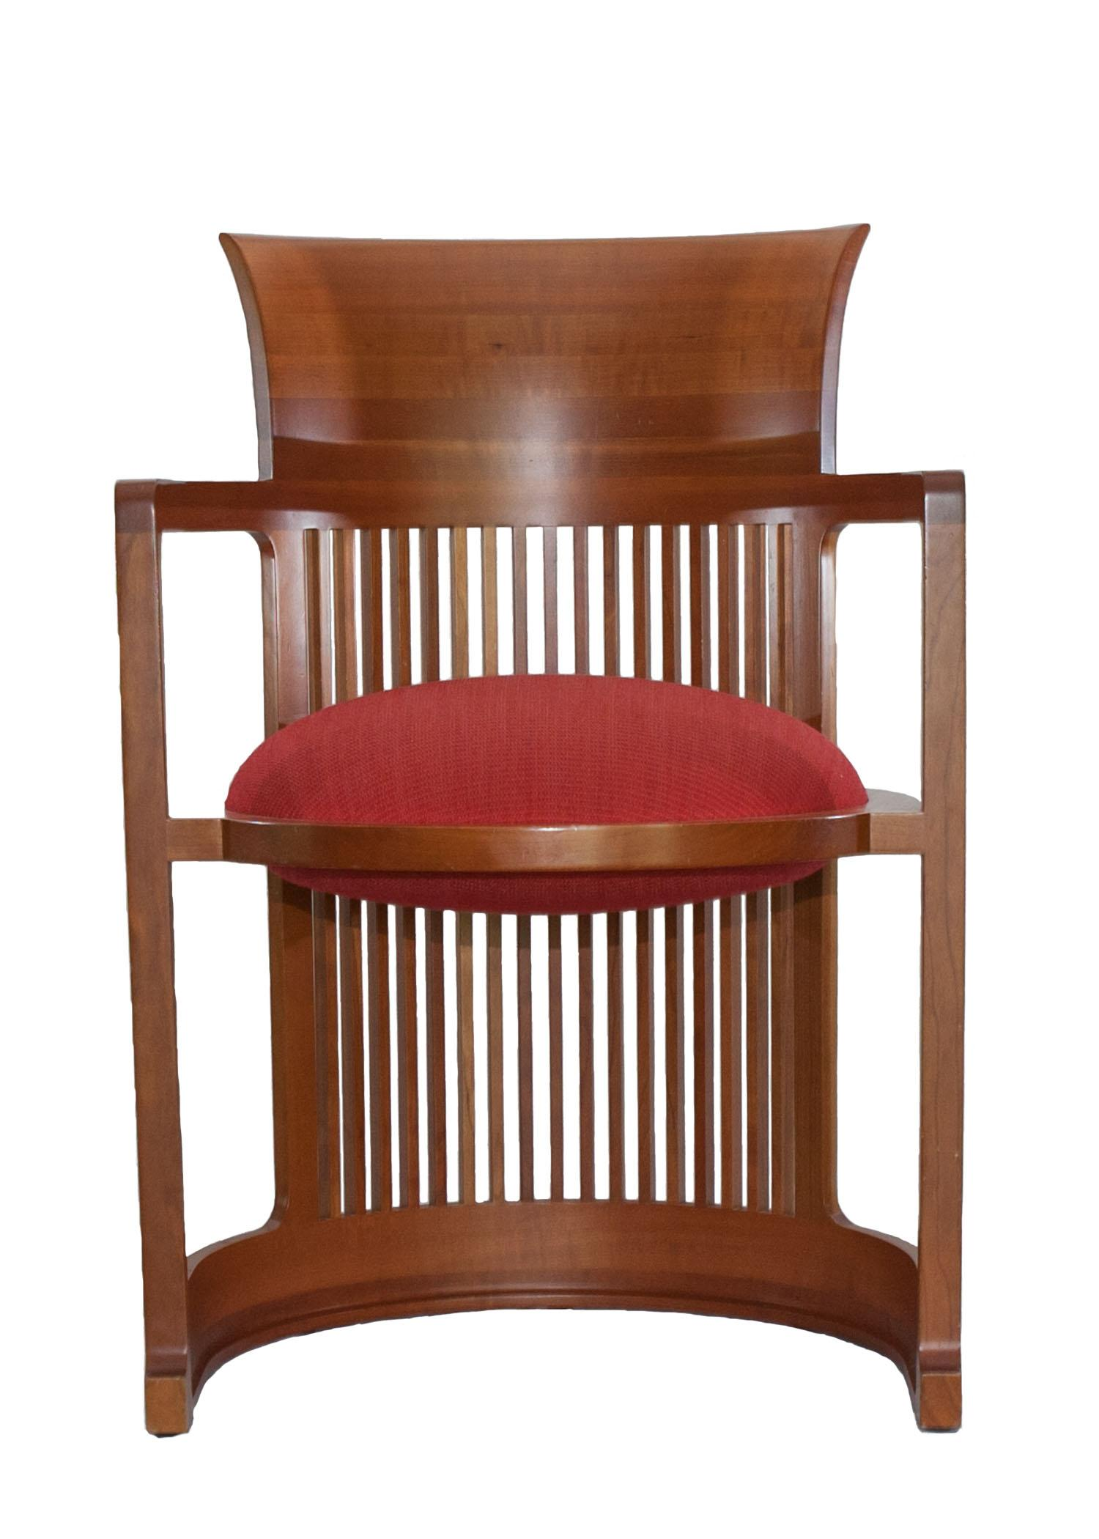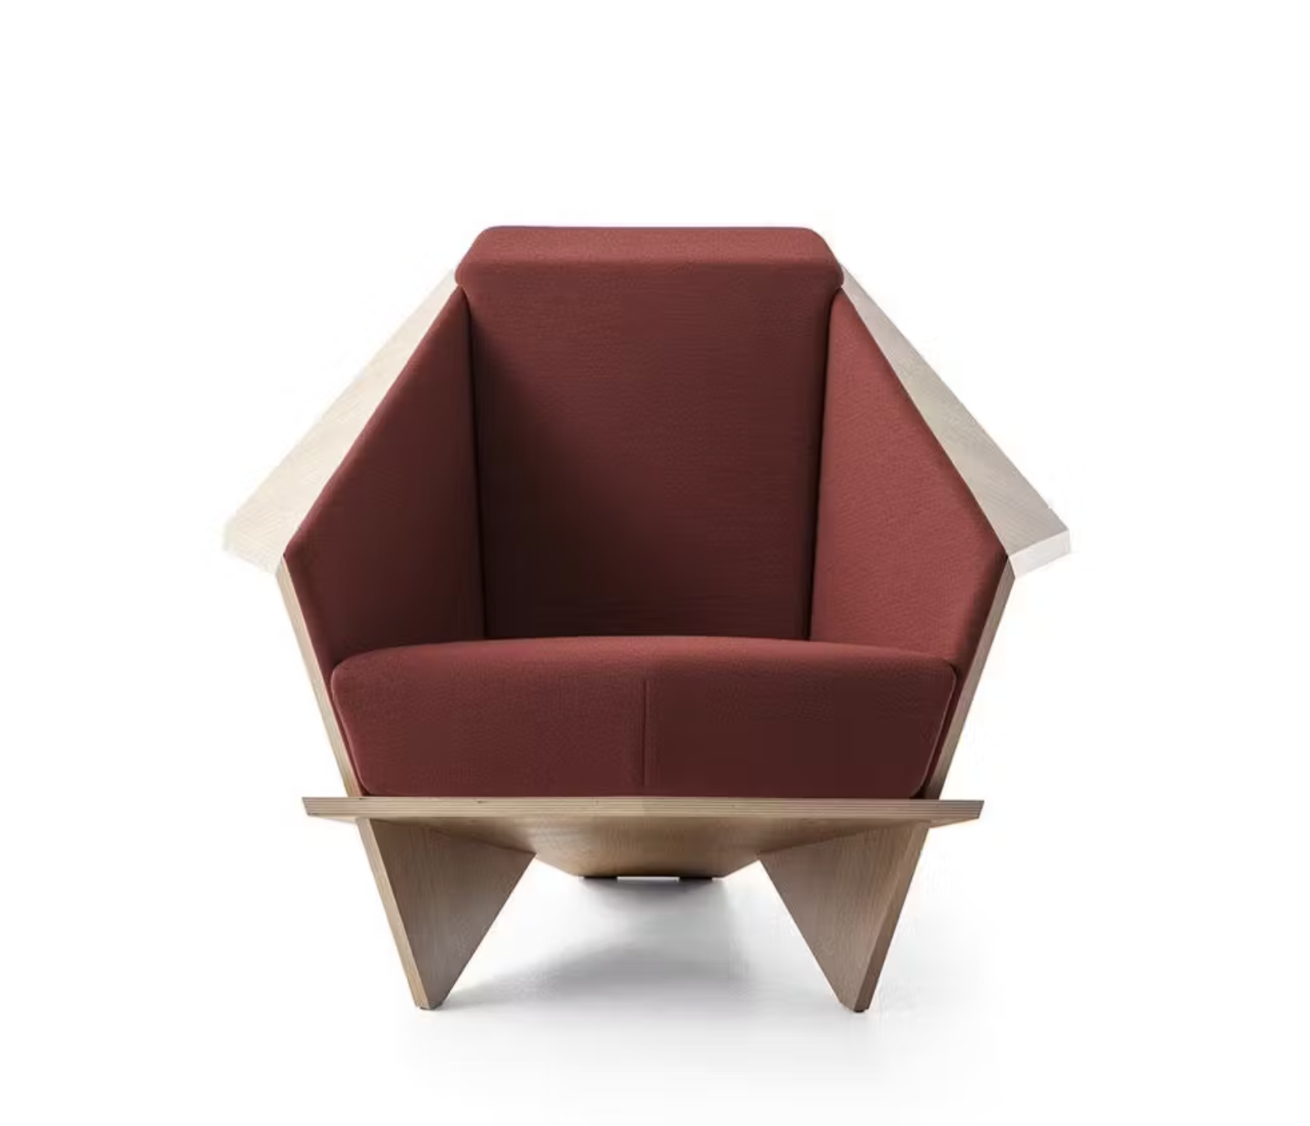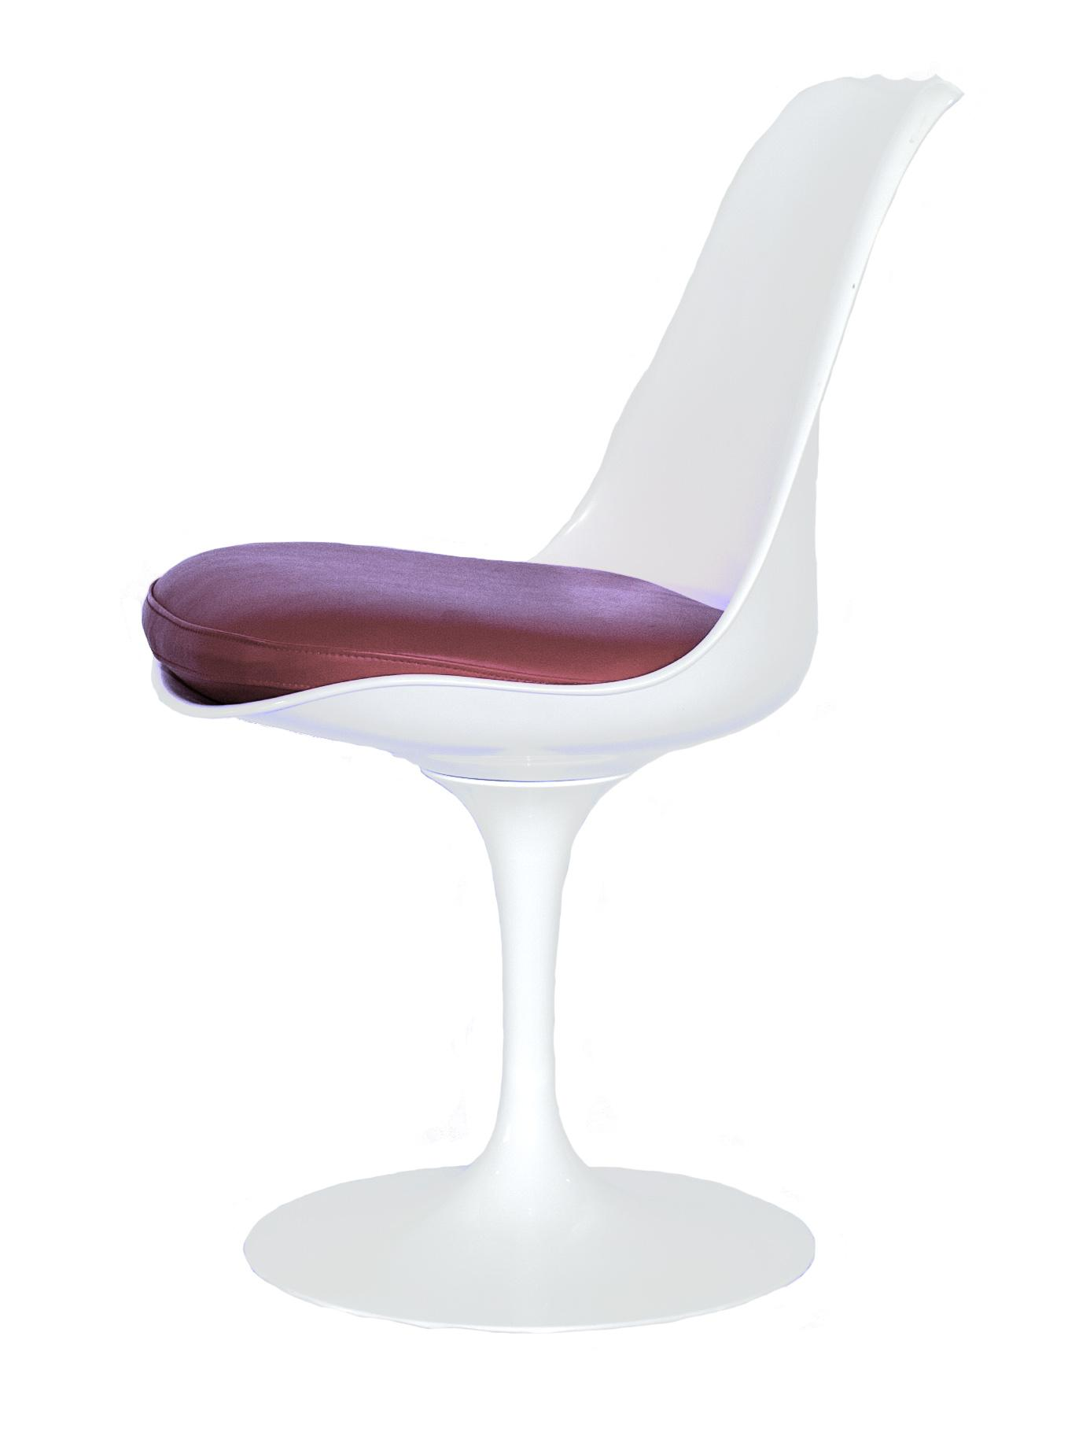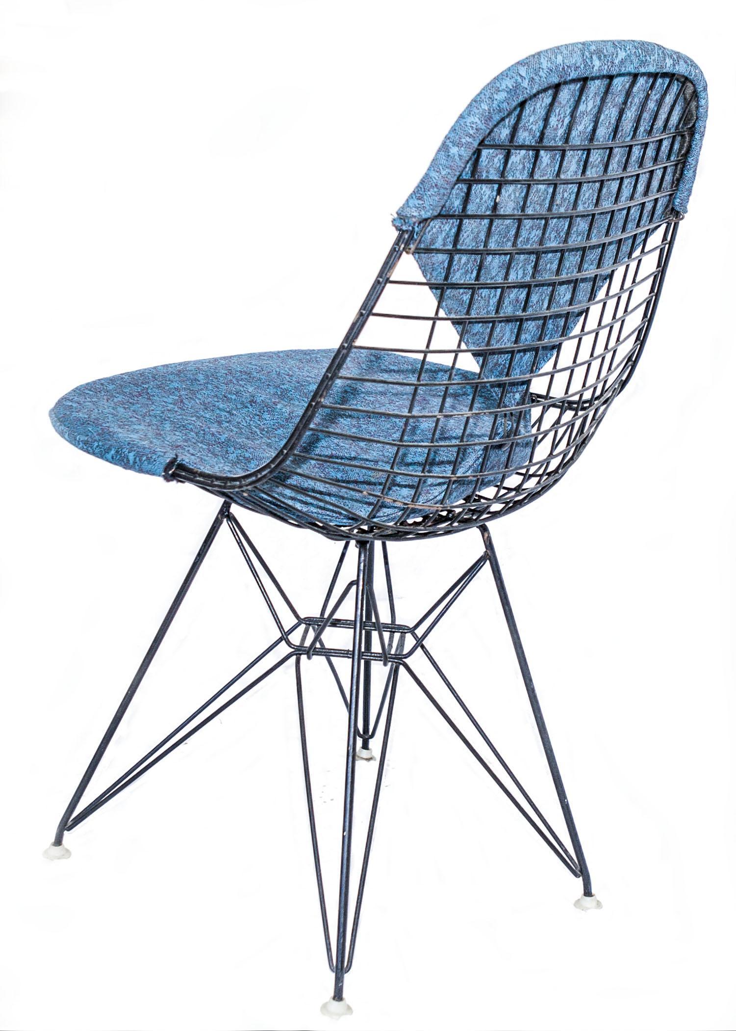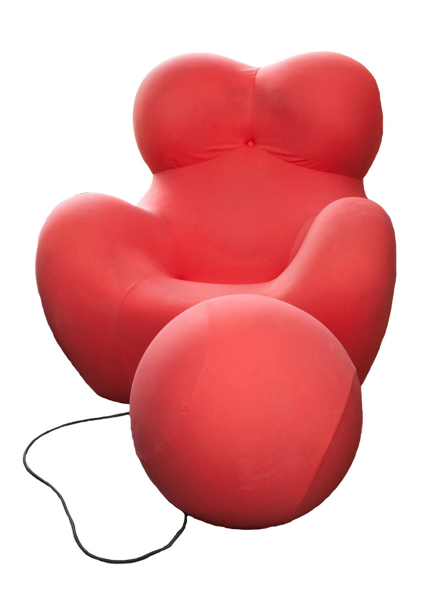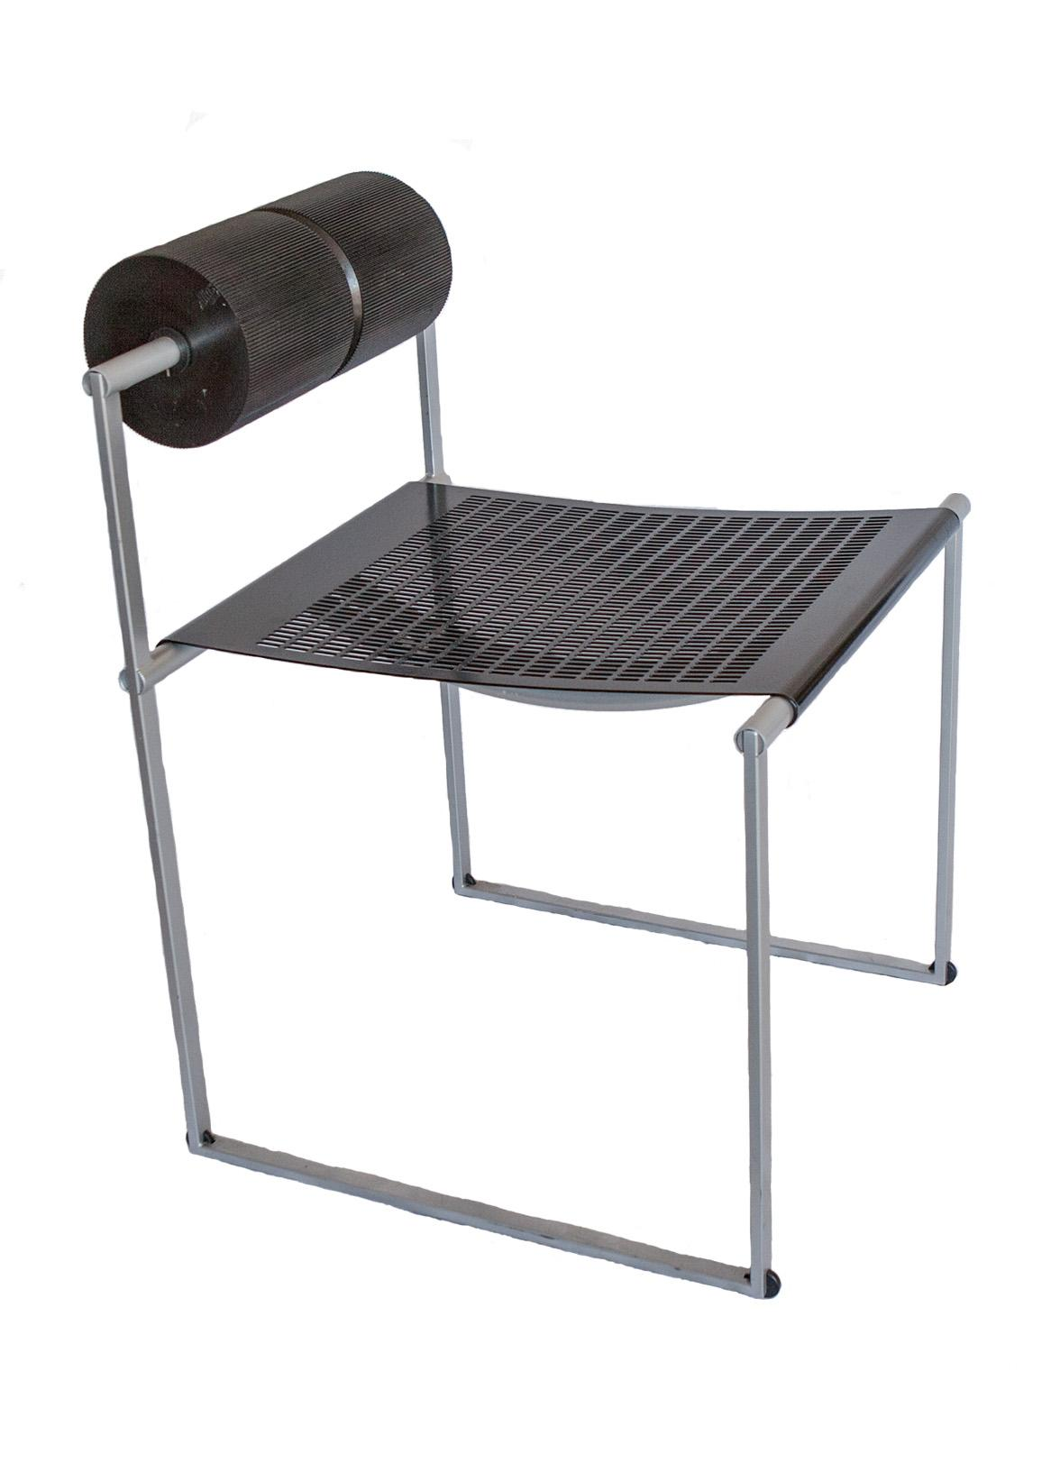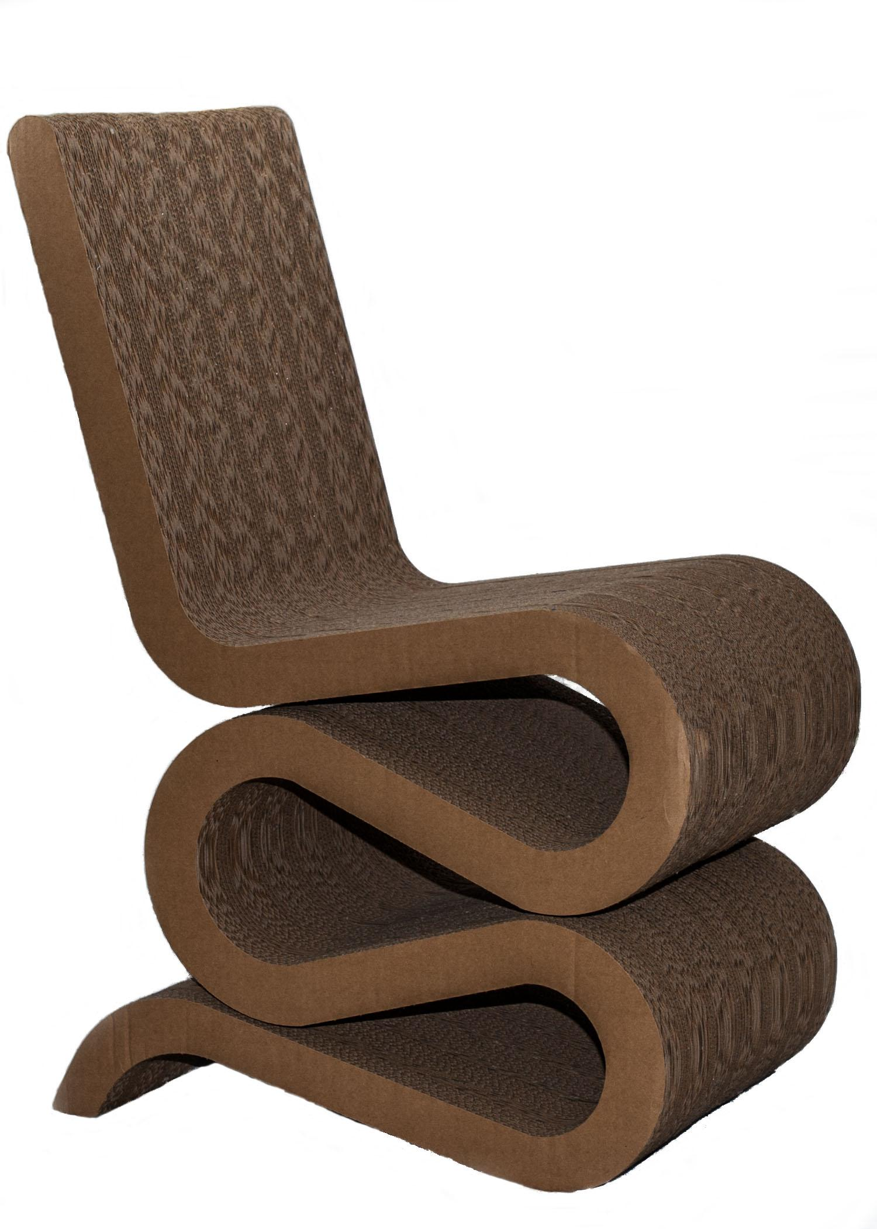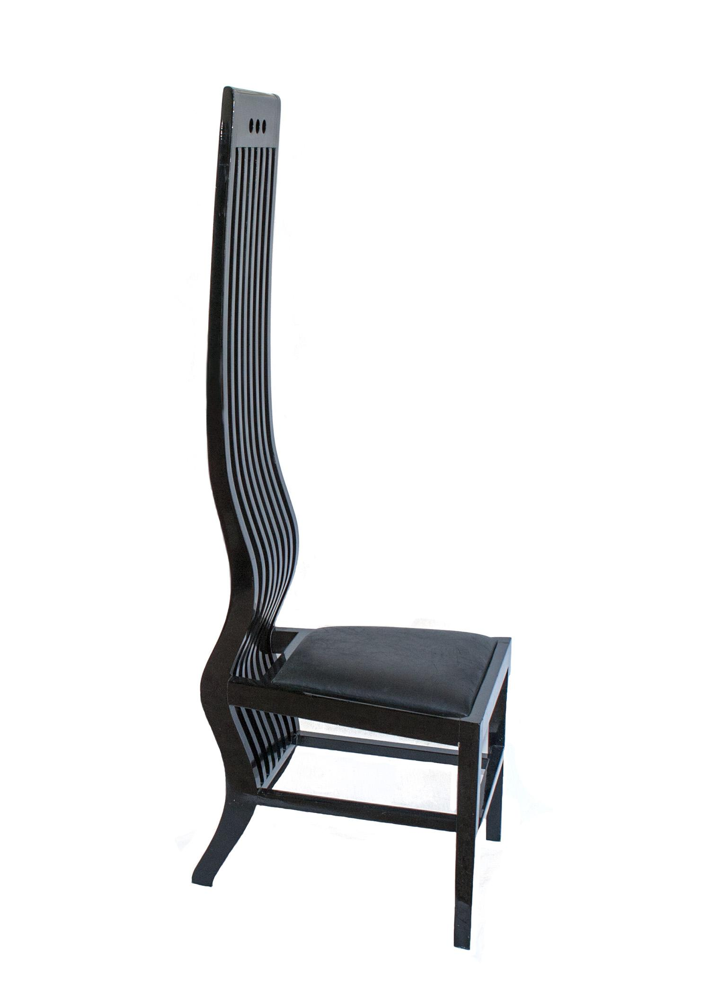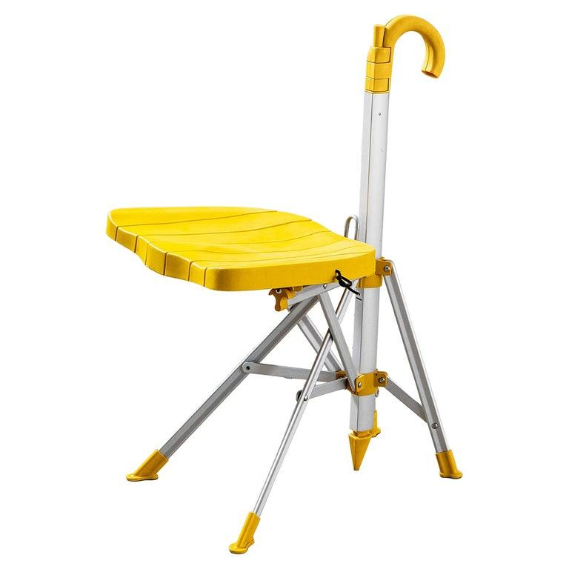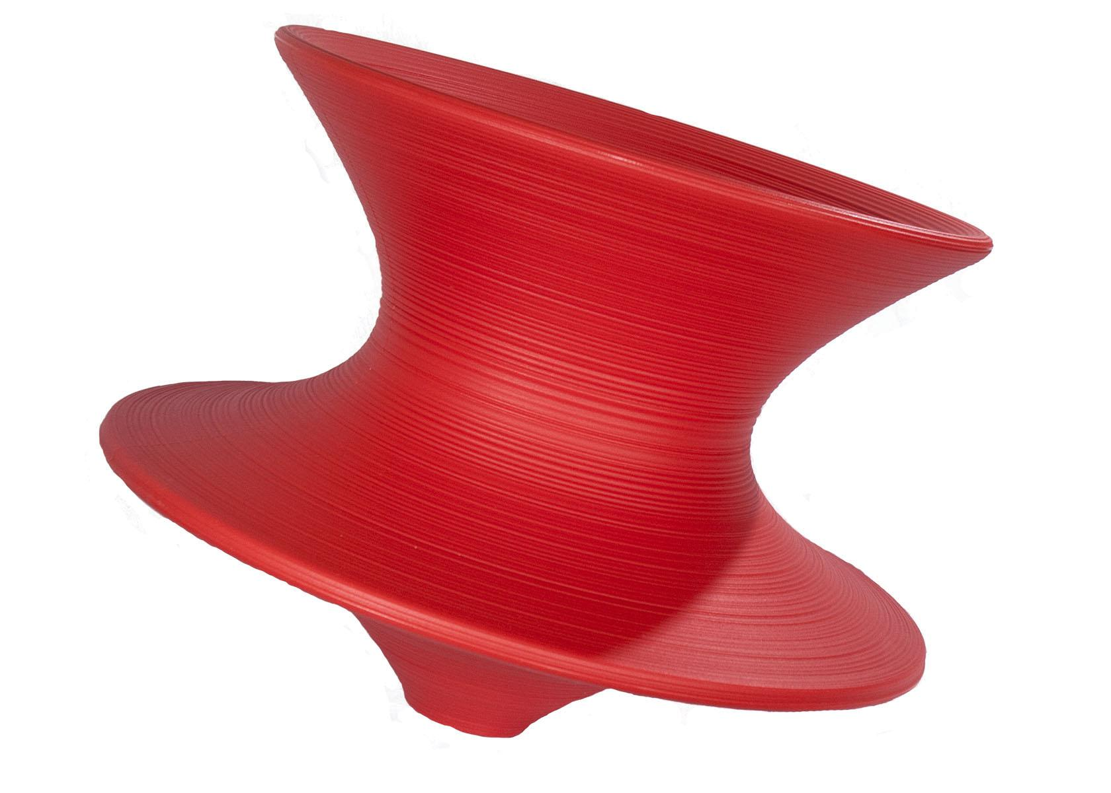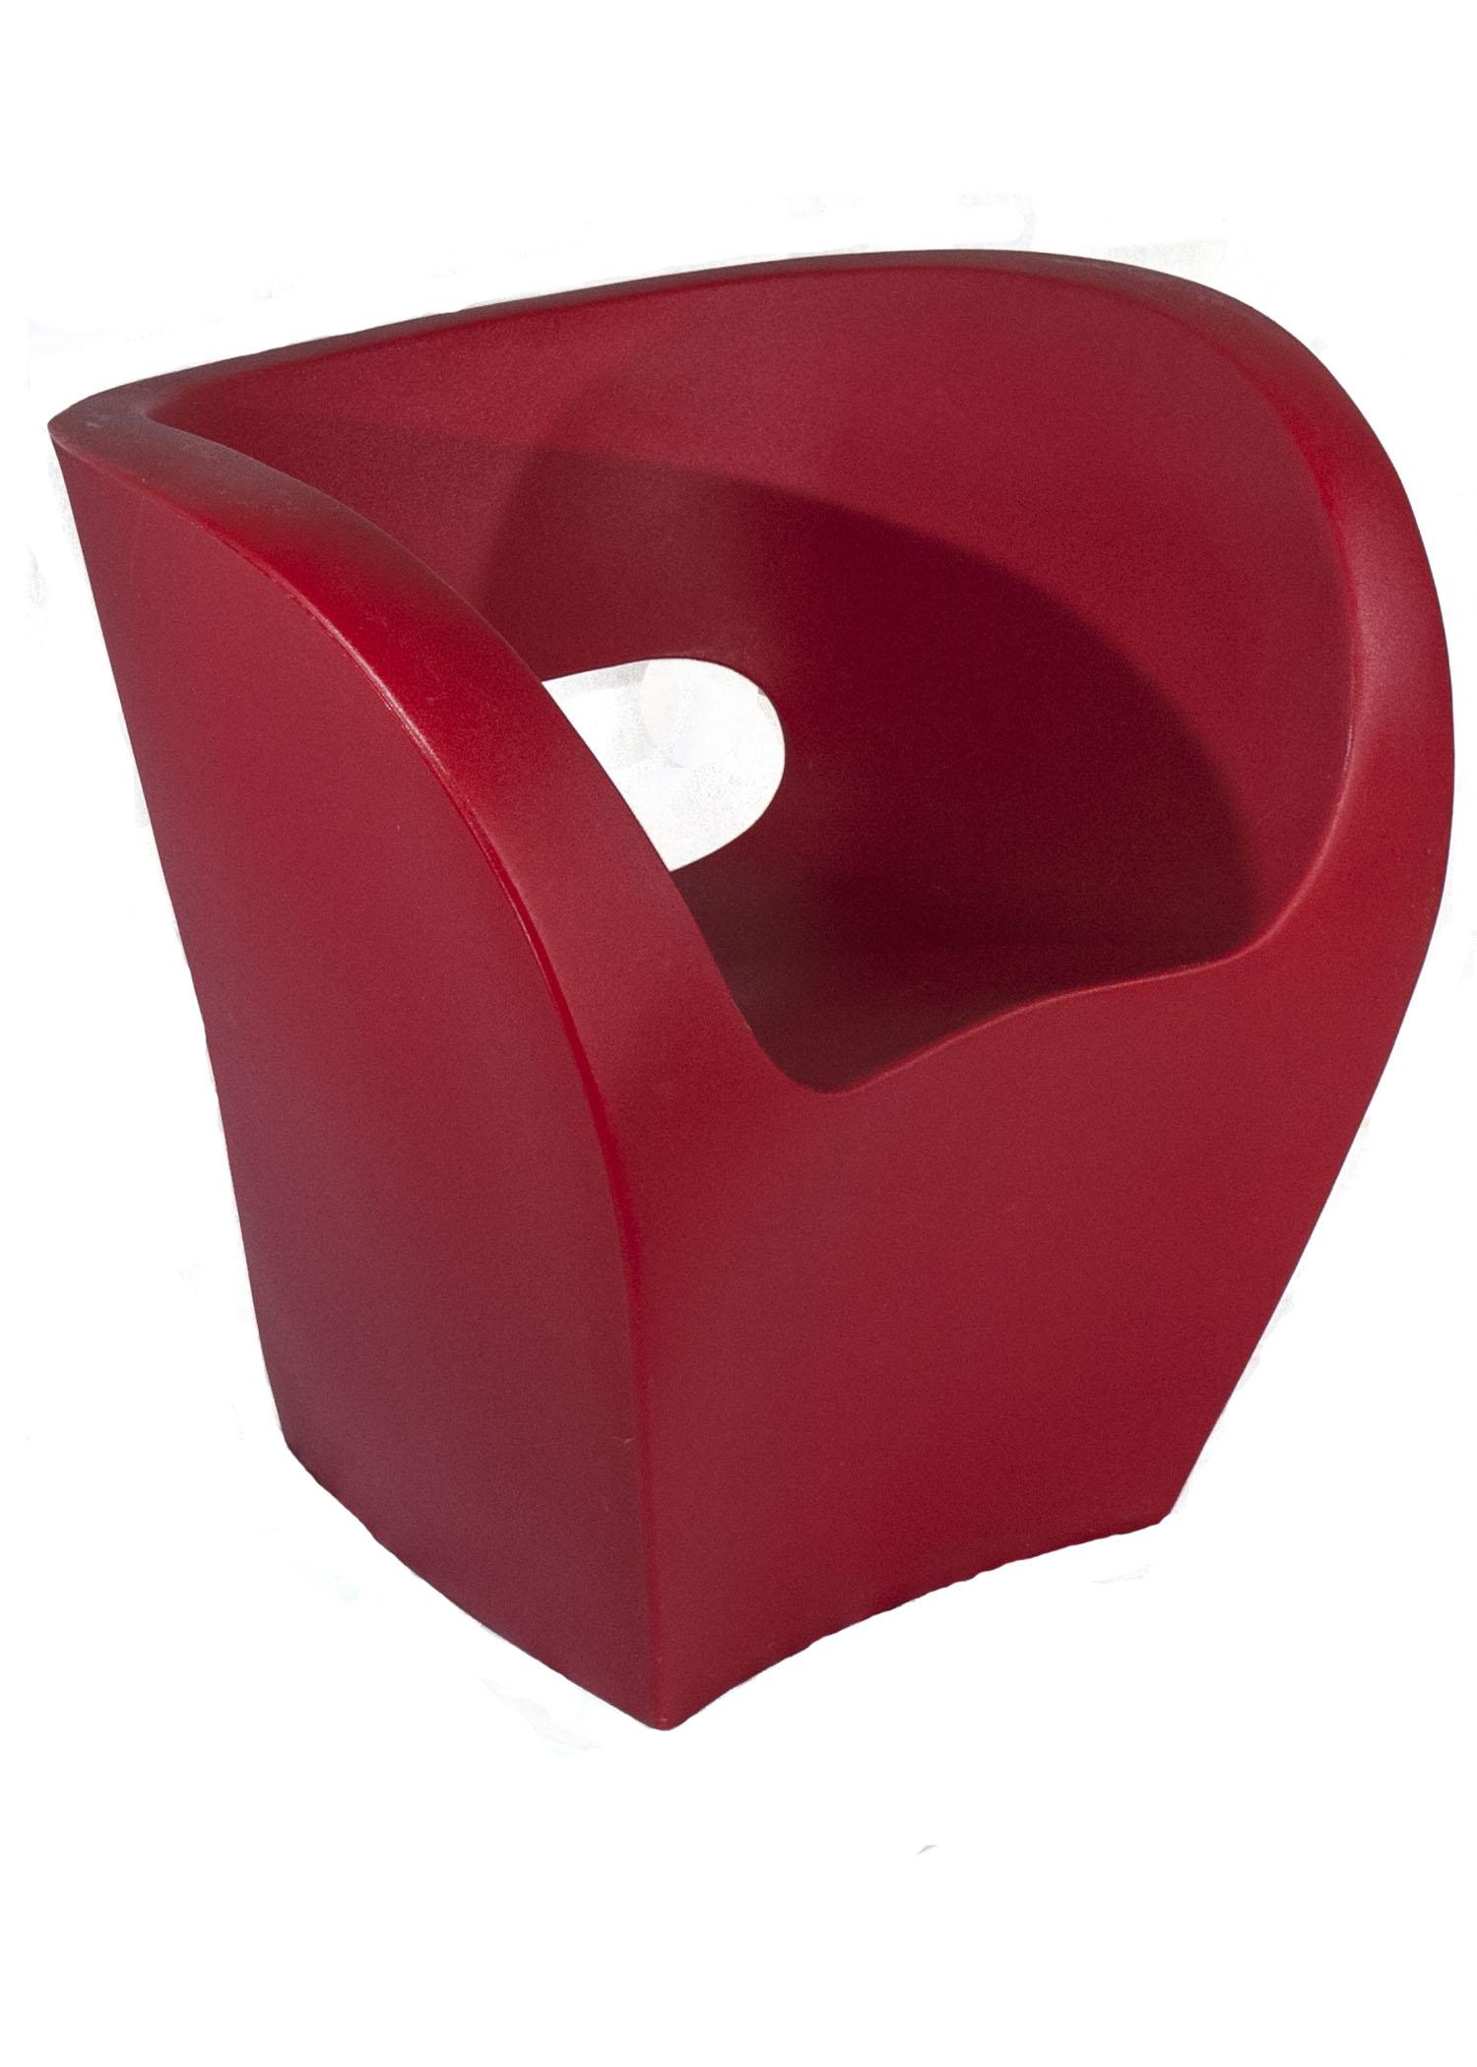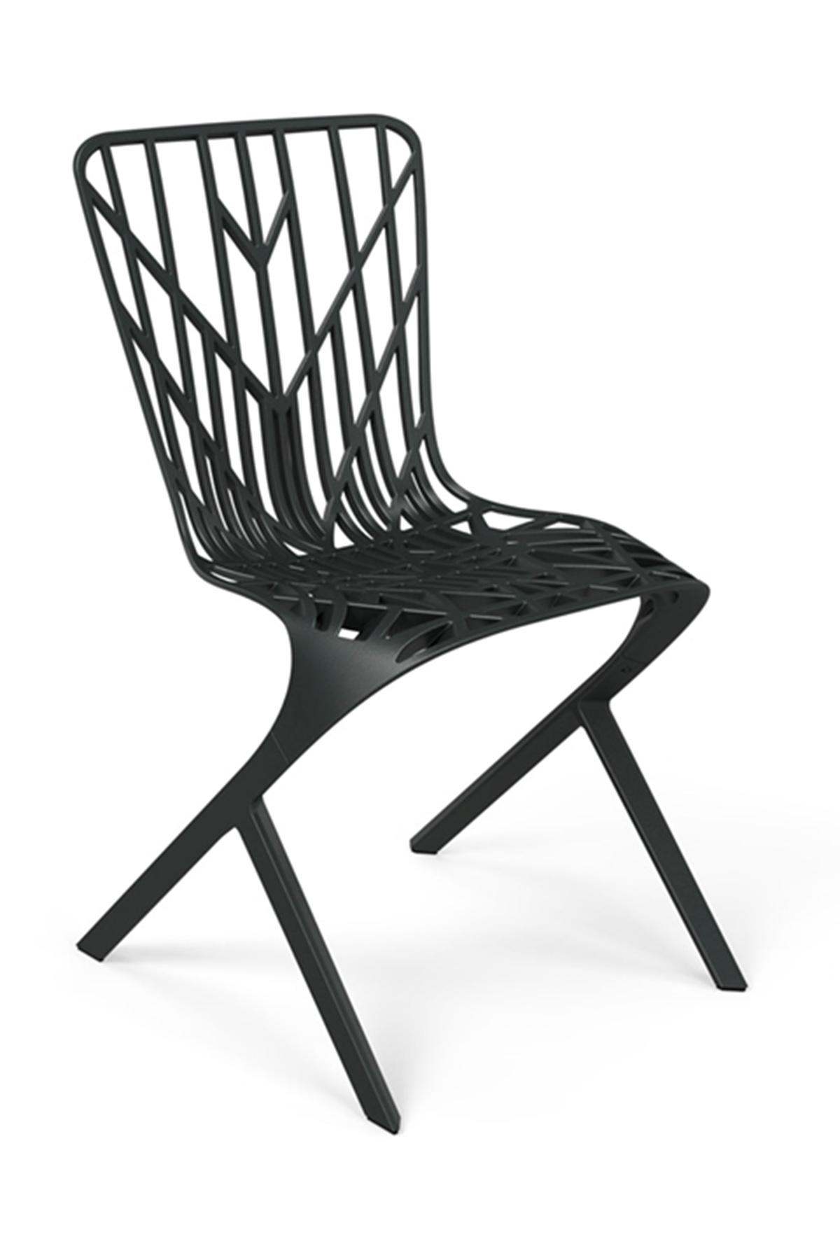

Antoni Gaudí,
Podouk Armchair, 1902

Key words:
Catalan Modernism
Organic forms inspired by nature and human physiognomy
Dynamism and expressiveness
Solid natural materials

Designed in 1902 for Casa Calvet, in Barcelona, Spain, this chair exemplifies Antoni Gaudí’s fascination for undulating forms inspired by nature and by human physiognomy. A style that is visible in many of his world-known buildings and public spaces and that has become an icon of Catalan Modernism.

As author Agata Toromanoff writes in her book “Chairs By Architects”: “Both designs - the chair and the building - are made of solid materials, the armchair of wood and the building of stone. Thanks to the curving lines, however, they gain dynamism and expressiveness (..) Gaudí’s approach to design results in shapes that are magical and imaginative, rather than adhere to the normal rules of architecture”.

More info about Casa Calvet, Barcelona, Spain.

Charles Rennie Mackintosh in collaboration with Margaret MacDonald
Hillhouse LadderBack Chair, 1904

Key words:
Scottish Art Nouveau
Rhythmic repetition
Structural as decorative
Symmetry

The work of architect/artist Rennie Mackintosh’s, artists Margaret MacDonald, Francis MacDonald, and Herber MacNair, better known as “The Four” was part of a broad movement called Art Nouveau, that spread across Europe and the United States from the late 1800s. This international style assumed different names in each country: Modernisme in Catalonia, Scottish Art Nouveau in Scotland, Jugendstil (Youth Style) in Germany. The movement was highly inspired by natural elements and forms, often already present in Celtic, Gothic and Japanese art and design, and it brought new interest in applied arts with an emphasis on craftsmanship.

Scottish Art Nouveau’s distinct features were the attention to geometry, restrained ornamentation and vertical lines. The Hillhouse LadderBack Chair is a perfect example of that. The chair is made from ebonized oak and its distinctive features are the exceptionally high back and its geometric design that elevates structural elements turning them into elegant decoration.

This chair was commissioned by publisher Walter Blackie as part of the furniture for Hill House, one of Mackintosh's architectural masterpieces in Helsenburg, Scotland, UK.
Learn more about Hill House, Helsenburg, Scotland, UK

Eileen Gray,
Bibendum Chair, 1926

Key Words:
Human-centered Modernism
Socializing and welcoming
Humor

The work of female artists and designers in western history has been often overlooked. Several famous designers including Le Courbusier, Breuer and Mackintosh worked closely with women who were pioneers in the fields of architecture, design and craft, but whose contributions and innovative collaborations with their male peers were often overshadowed by society’s lack of acceptance of the professional accomplishments of women.

Irish designer Eileen Gray is one among these influential female creatives whose work is today being rediscovered and appreciated. She was one of the first women to attend Slade School of Fine Art, she mastered Japanese lacquering, experimented with textile techniques and started her own business in Paris after the First World War. In 1926, Gray designed “Bibendum” an armchair with a unique design made of stainless steel tube and polyurethane with polyester fiber. The official name is a clear and somewhat humorous reference to the French name for the Michelin Man or Michelin Tire Man, the famous mascot of the Michelin tire company, and is designed to be welcoming, comfortable and encourage socializing.

Gray’s take on Modernism exemplified her attention for comfort and the rejection of a rigid rationality and cold austerity, rather embraced by other contemporary (male) exponents of this current. This is visible in the E-1027, a house built in 1929 for Gray and her lover Jean Badovici.
Located right on a slope above the french Côte d’Azur, E-1027 is oriented to best catch the sun and deal with the coastal wind. Each room has access to a balcony, a system to control the natural light, and adjustable furniture, giving each occupant agency to customize the space to optimize their comfort and well-being.
Learn more about EE-1027, Roquebrune-Cap-Martin, France.

Marcel Breuer and Margaretha Reichardt
Wassily Chair, 1925

Key Words:
Modernism
Light and sturdy
Minimalist

Marcel Breuer’s practice and research deeply influenced European design and architecture worldwide. Born in Hungary, Breuer spent about a decade at Bauhaus university in Germany, studying, teaching and experimenting. There he developed some of the most innovative chairs recorded in history including the 1925 Model B3 chair, later renamed Wassily Chair in the nineteen-sixties. The name is an homage to the famous abstract modernist painter Wassily Kandinskij, who was a great appreciator of Breuer’s work and especially the Model B3, which he purchased for his studio when it was first released in 1925.

The inspiration for this chair came from observing the lightness and sturdiness of the materials used for constructing bicycles, especially tubular-steel. When it was first produced, the Model B3 came in a folding and non-folding version with straps made of Eisengarn or 'iron yarn' a strong, shiny, waxed-cotton thread perfectioned appositely to be used in Breuer’s chairs by Margaretha Reichardt a students at Bauhaus. This icon of modernist design opened up new paths for design and manufacturing that are still used today.

After leaving Germany to flee the oppressive nazi regime, Breuer dedicated himself to architecture, leaving an indelible mark on Minnesota with several of his notable buildings. Between 1953 and 1975 his architecture firm designed twelve buildings for the expansion of the Campus of St. John’s University in Collegeville, MN. These included the Monastic Residence, Saint Thomas Hall, The Abbey & University Church, Alcuin Library, the Peter Engel Science Center, The Collegeville Institute for Ecumenical and Cultural Research, and Saints Bernard, Patrick, and Boniface Halls.

The University leadership was looking for a campus that would communicate and reflect upon the contemporary beliefs and position of the Benedictine’s house in the world. Therefore the choice of selecting an architect who exemplified mid-century Modernism, like Breuer, appealed to them due to the use of unusual, sculptural forms, undisguised materials, and unique aesthetic. The St. John Abbey, with its exposed concrete walls and solidly built large scale bell tower, is an excellent example of this brutalist architecture and, just like the Wassily Chair, shows Breuer’s contribution to an aesthetic where structure and aesthetic converge.

Learn more about St John’s University Campus, in Collegeville, MN: Monastery Residence Building (1955), Abbey Church (1958), Saint Thomas Hall (1959) , Abbot Peter Engel Science Center (1965), Alcuin Library (1966), St. Bernard Hall (1967), St. Boniface Hall (1967), St. Patrick Hall (1967), Collegeville Institute, formerly called the Ecumencial Institute (1968) , Warner Palaestra and the Warner Palestra Sculpture (1973), Bush Center (HMML) (1975)

Frank Loyd Wright
Taliesin Barrel Chair, 1937 and Taliesin West Origami Chair, 1946

Key words:
American Art Deco/Prairie Style
Integration between object and environment
Unity of construction (origami)

Frank Loyd Wright is considered to be the father of American Art Deco, a movement that, building upon European Art Deco’s influence, was distinguished by simple, geometric lines and continuity of construction. This aesthetic of continuity is visible in Wright's furniture design as well as architectural projects. Seemingly modeled from a single piece of materials, Wright’s most famous architectural endeavor, the Guggenheim Museum, was completed in 1959 in the heart of NYC. The building stands out in contrast to the verticality of the Manhattan skyline, thanks to its low, white, continuous and spiraling profile. Similarly, the Taliesin West ‘Origami’ Chair, designed in 1946 for the Wright's home studio in Arizona, is masterfully fabricated from a single, folded panel of laminated birch plywood, and the Barrel Chair achieves the illusion of continuity through the use of curved wood.

Originally crafted in cherry wood in 1904 for the D.D. Martin House in Buffalo, NYC, the Barrel Chair was perfected in 1937 for the “Wingspread” Herbert Johnson’s house in Wind Point Wisconsin. Both houses were created in Wright’s distinct “Prairie Style,” and they were inspired by the flat, vast landscape of the American Midwest. The style was characterized by the use of natural materials, simple geometric low design, and an attention to the building's relationship to its surrounding environment. The same attention to continuity and an intentional integration of landscape and architecture, indoor and outdoor, and design and the human body, is again carried in the design.

Wright designed many buildings in the Midwest, and many are open to the public.

Learn more about Frank Lloyd Wright’s architecture in the Midwest.

Ray and Charles Eames
DKR-2 Dining Bikini Rod Chair, 1951

Key words:
Innovative use of construction materials
Prefabricated components
Wire mesh

The DKR-2 Dining Bikini Rod Chair is part of an exploration by architects Ray and Charles Eames of using welded wire to fabricate a chair from a single material.. Their exploration resulted in a series of chairs named Wire Chairs, that showed various ingenious solutions for the design of the base and the cushions. While “DKR” stands for Dining height (D), K-Wire chair (K) , on Rod base (R), “2” refers to the upholstery in two pieces: seat and back. The two pieces are tied by a button in the center, resembling a bikini swimsuit. One of the great achievements of this exploration was the ability to develop manufacturing processes that allowed for using high-quality materials while reducing production costs.

With a similar attention to innovation and inexpensive production techniques, the couple built the Eames House in Pacific Palisades, California in 1949. Following the Second World War, the magazine Arts&Architecture sponsored a programme called Case Study House, encouraging architects to design homes with innovative, efficient, affordable materials and techniques. Ray and Charles Eames adopted prefabricated parts, such as doors, factory windows and other materials used up to that point exclusively for the construction of commercial buildings. The result is a multifunctional, luminous, essential space that became both a home and a studio for the two architects.

Learn more about the Eames House in Pacific Palisades, CA.

Eero Saarinen,
Tulip Chair, 1955

Key words:
Sculptural quality
Natural grace and balance
Color as a media

The Tulip Chair is part of a larger collection created by Finnish architect Eero Saarinen as the culmination of a life-long research on simplifying and beautifying the aesthetic of the supports in tables and chairs. The solution found by Saarinen for the Tulip Chair, manifests in a curved pedestal base, resembling a flower stem, that supports a sculptural fiberglass seat and offers spacious legroom. While the chair seems to be molded from one single material, it is actually resting on an aluminum stem wrapped in a plastic finish. Due to its distinct elegance and sculptural forms, elements from Tulip Collection have appeared in many well-known movies and tv shows including “Grace and Frankie” and “Mad Men”.

Saarinen was devoted to pushing the boundaries of materials and manufacturing techniques to reach his innovative aesthetic goals. One great example of this is the 1956 IBM Manufacturing And Administrative Center in Rochester, built in Rochester, MN, to symbolize the corporation’s faith in progress and technology. For the exterior, Saarineed experimented with a thin membrane applied to the glass walls whose color granted the building the unofficial name of “Big Blue”. The color is inspired by the vibrant tones of Minnesotan lakes, sky and rivers and was intentionally chosen by the architect to visually stand out throughout Minnesota’s seasons: against the deep green of the summer grass as well as the bright white of the winter snow. In a modernist attempt to merge aesthetic values and functionality, contemporary and historic, Saarinen designed a campus that was fit for a mixed use of research, design, engineering, production and distribution.

More about “Big Blue” IBM Manufacturing And Administrative Center in Rochester

Gaetano Pesce,
Up 5 Lounge Chair with Up 6 Ottoman, 1969

Key words:
Radical Design
Expanding and growing
Non-conventional design

Informally named “Big Mama” or “La Mamma”, the Up 5 Lounge Chair with Up 6 Ottoman is one of the most iconic designs of the 1960 and a great example of Radical Design. The Radical Design movement was driven by an avant-garde approach to design that encompassed writing, art, experimental filmmaking, teaching theories and industrial design. Exponents of Radical Design were moved by political and utopian aims to provide modern alternatives for urban architecture, material innovation, and environmentally driven solutions. Made of polyurethane foam covered in stretch fabric, the Up 5 marks a milestone in the research on packaging and expansion: the chair is packaged as a four-inches-thick disk and when it is removed from the vacuum PVC envelope, it grows to assume the shape of a large, soft female body.

Because of its distinctive appearance, the Up 5, has been exhibited in museums around the world and it is present in many collections including the Philadelphia Museum of Art and the Museum of Modern Art in NYC.

While the artist conceived this reference to the body as a political commentary on women’s freedom and equal rights at the peak of the second-wave feminism, in recent years Up 5, has been criticized for fetishising the female body and reinforcing gender binarism and stereotypes, that link femininity with caregiving and fertility.

Learn more about the Organic Building, Osaka, Japan

Frank Gehry,
Easy Edges Wiggle Side Chair, 1972

Key words:
Ecodesign
Bold, sculptural, sinuous forms
Resilience and strength

The Easy Edges Wiggle Side Chair is part of Gehry’s groundbreaking Easy Edge collection, a series of chairs, chaise lounge and footrests made of laminated cardboard. The series was designed between 1969 to 1973 and is one of the first examples of Ecodesign. Ecodesign is an environmentally conscious approach to the design and production of objects that employ recycled materials and low impact production strategies. To create this chair, Gehry took advantage of the versatility, flexibility and sturdiness of layered, sandwiched, and pressed cardboard, to create an object with a bold sculptural presence and unexpectedly fluid lines.

This sculptural approach to forms is visible across Gehry’s architectural, design and artistic work and it informed iconic buildings including the Weisman Art Museum (WAM) in the University of Minnesota campus in Minneapolis. Designed in a deconstructivist style, WAM’s facade presents massive curves that give a dynamic yet solid look to the building.

Inside of the museum it is also possible to view Gehry’s large-scale sculpture Standing Glass Fish (1986), formerly installed in the greenhouses in the Minneapolis Sculpture Garden. As independent curator Elise Armani writes in an article on wam.umn.edu: “The form of a fish has been a long recurring motif in Gehry’s creations, and he has called its shape “the perfect form.” His fascination with fish began as a child of a Jewish family in Toronto when his grandmother would travel to the Jewish market every Thursday morning to purchase a carp for gefilte fish. The large carps, sometimes 3 feet long, would swim in the bathtub at Gehry’s home until it was time for them to be killed and Gehry would sit near the bathtub and watch them swim. Gehry has used the image of these childhood carps in various projects of various scales since the early 1980’s. The motif is most commonly found in his fish lamps, one of which resides in the Riverview Gallery of the Weisman Art Museum.”

Learn more about the Weisman Art Museum, Minneapolis, MN.

Arata Isozaki,
Marilyn Chair, 1973

Key words:
Surprise and illusion
Vantage point
“Thoughts Beyond Architecture”

This iconic chair designed by Japanese architect Arata Isozaki for the executive office of a bank, is a tribute to the history of chair design, to pop culture, and to elegant sophistication but with a twist. Viewed from the front, the chair’s high back is reminiscent of the geometric design of Mackintosh's Hillhouse Chair, but the side view of the Marilyn Chair surprises with an undulating curve, materializing the silhouette of actress Marilyn Monroe, who Isozaki cited as the inspiration for the curves he often introduced in his work to challenge right-angle, straight-line geometries.

Creating illusion through the possibilities of tri-dimensionality and inviting the viewer to actively engage in discovery is a signature trait of Isozaki’s practice across disciplines. For the design of the M2 Concert Hall in Thessaloniki, Greece, Isozaki adopted a similar technique that emphasizes the importance of a vantage point when looking at tri-dimensional objects: as you stand in front of the building, the facade appears simple and spacious, balanced in its geometrical design. But when you walk around the building, the unity of the facade breaks as an unexpected mix of various construction materials and volumes are revealed.

This attention for a vantage point can be connected to the architect’s upbringing: growing up in Oita, Japan, near the site destroyed during the second world war, Isozaki witnessed the the void of architecture left by the atomic bomb and focused his life’s work on the possibilities within that void to imagine and build a better, more hopeful future.

Learn more about the M2 Concert Hall in Thessaloniki, Greece.

Mario Botta
Prima Chair, 1982

Key words
Archetype
Imposing geometrical forms
Emphasis and Rhythm
Inspired by geometry’s archetypal forms, the Prima Chair by Swiss architect Mario Botta, is composed of a clean lacquered steel structure, a seat in lacquered perforated steel, and a cylindrical backrest in polyurethane.‎ His predilection for geometrical, archetypal shapes defines Botta’s distinct style and conveys a sense of balance, order and symmetry across his work.

For Botta the design of an object or a building was informed by carefully observing and knowing a site. For example, understanding how light plays in a space was fundamental to Botta’s design process as light can define or even generate space, balance a structure and provide emphasis and rhythm, bringing a design to completion. This is visible in his chair design as much as in his architecture. Imagine the light playing through the perforated steel of Prima Chair, and imagine the parallels to light shining through the skylight of a building.

At the Museum of Modern Art in San Francisco, for example, the iconic and perfectly rounded skylight on the facade from outside reminds us of an eye constantly watching or casting a light of knowledge over the city. The opening of SFMOMA on Third Street marked the beginning of a cultural transformation that brought the area global recognition for its vibrant and rich range of galleries and museums.

Learn more about San Francisco Museum of Modern Art, San Francisco, CA.

Gaetano Pesce,
Umbrella Chair, 1995

Key words:
Radical Design
Playfulness
Multiplicity of use

The practice of Italian designer Gaetano Pesce is characterized by a playful and experimental outlook on form, shapes and multiplicity of use. Made of anodized aluminum with polypropylene and nylon reinforced with glass fiber, the Umbrella Chair is light and easy to transport: by pressing on a button, the chair assumes either the function of a walking stick or a seat. Stemming from his past experience within the Radical Design movement, Pesce’s choice of color is often bold and aimed to highlight his innovative approach to contemporary materials and user interaction. The Umbrella Chair is produced in the four primary colors and its multimodal use expands on its primary function as a chair.

These principles and practices are carried in Pesce’s architectural projects and exemplified by the Organic Building completed in 1993 in the city of Osaka, Japan. The facade and external walls of the Organic Building are made of steel-encased concrete panels covered by a red glazed finish. The panels are arranged in a grid and feature extruded pockets, of various sizes and shapes, filled with more than 80 different kinds of indigenous plants. The plants are supported by a system of controlled irrigation and drainage. This unique urban vertical garden was created in collaboration with local horticulturists and its bright, earthy color stands out among the muted gray tones of the surrounding buildings, demonstrating, once again, Pesce’s drive for innovation and play within his works.

Learn more about the Organic Building, Osaka, Japan

Rod Arad
Little Albert, 2000

Key words:
Continuous flow
Infinite line
Dynamism
Little Albert is part of a larger collection produced by the Italian company Moroso and designed by Israeli architect Ron Arad. The collection is characterized by a continuous flow of curving lines that recalls a drawing created without lifting the pencil off the paper, and conceptually an idea of infinity and balance. Produced by using a rotational molding process, Little Albert is made of 100% recyclable colored polyethylene that makes this armchair suited for indoor and outdoor settings.

The fluidity and dynamism of lines is present across Arad’s design and architectural work. For the creation of the Design Museum in Holon, Israel, Arad used a series of large steel ribbons that embrace the building and challenge visitors’ perception once they enter the space, while also offering structural support. This attention for a visual flow that feels organic and dynamic is also embraced practically by the architect when creating multiple ramps and points of access to the building that reflect the mission of the museum to embrace Israel’s growing creative presence in the field of design.

Learn more about the Design Museum in Holon, Israel

Thomas Alexander Heatherwick
Spun Chair, 2010

Key words:
Experimental fabrication techniques and materials
Form defined by material
Spinning

Spun Chair was created through an experimental process while the architect was testing out the possibility of metal spinning. Later the prototype was industrially produced using rotational molding and polyethylene, which allowed for creative colors and improved ergonomics. The chair has a playful sculptural aesthetic that is functionally matched by its ability to rock side to side and spin around.

The experimental focus and the spectacularity of the form is visible in Heatherwick’s architectural projects like the UK Pavilion built in Shanghai, China in 2010. In Chairs by Architects, Agata Tormanoff writes “Like the chair, the idea was to experiment with the materials, which becomes more than just a surface: it defines the form.” Informally called the Seed Cathedral, the UK Pavilion looks at the same time majestic and soft with its surface made of 60,000 acrylic rods ornated on their tips by 25,000 seeds donated by the Kew Gardens’ Millennium Seed Bank.

Learn more about the UK Pavilion in Shanghai

David Adjaye
Washington Skeleton, 2013

Key words:
“Sculptural approach to volume” (Toromanoff, 2016)
Skeleton leaf
Social action

David Adjaye is one of the most influential living architects and designers whose visionary work is characterized by surprising juxtapositions of materials, inventive solutions for constructions and a distinct sculptural approach. Influenced by his extensive travels around the world, Adjaye states in his official biography on adjaye.com, that architecture is “a social act”, a means to celebrate and understand history, innovate and “serve communities into their futures.”

This is visible in the construction of the Abrahamic Family House in Abu Dhabi, UAE. The design of the three buildings in the Abrahamic Family House complex, emphasizes the unity of faith over differences among religions. Formally it presents a balanced mix of strong support and elevated suspension, universal geometry and different orientation.

Adjaye applies these principles to many of his designs including his furniture design. Constructed from a single piece of die-cast aluminum, the body of the Washington Skeleton Chair, features a geometric symmetrical design of triangles, squares, rectangles, and chevrons that recalls the elegant structure of a skeleton leaf, a universal symbol for unity among man and nature.

More about the Abrahamic Family House in Abu Dhabi, UAE

